**School of Electrical Engineering and Computing**

**SENG2260 – Human-Computer Interaction**

**Lab 7: Usability testing of a large website**

Week 8

# Usability testing of a large website: UON website

## The Goal

UON ([www.newcastle.edu.au](http://www.newcastle.edu.au)) has a large website to provide information to students, staff, researchers and the general public.

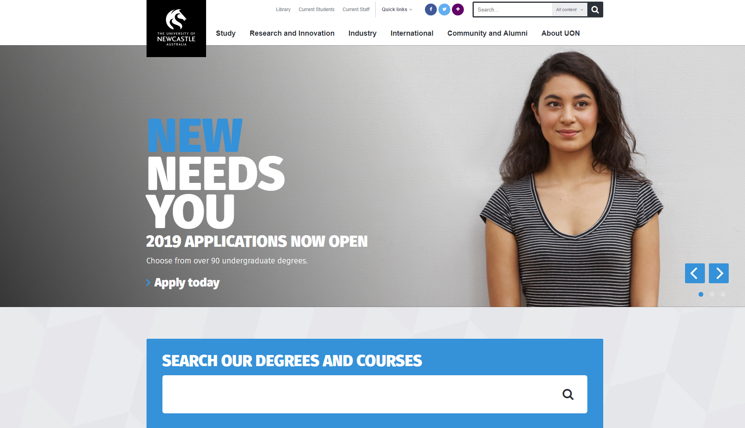

The object of the exercise is to test the UON website for usability. The goal is to check that the site is efficient, effective, safe, easy to learn, easy to remember and satisfying to use.

Usability problems should be identified, in particular technology errors (bugs), human errors and time taken to execute tasks. Remember the test is on the website, not the participants.

For today, consider all participants are representatives of the general public.

## The Exercise (15 minutes)

In groups, sketch out 3 scripts for the participants;

1. An introductory script explaining the aim of the exercise and introducing the testing procedure, inform them that they should “think out loud” and assure them that their anonymity will be respected.
2. An explanatory script describing the procedure. Define the goal (to identify features that could be improved as well as features that are especially helpful), and the process. This last will include whether time is given for the participant to familiarize themselves with the website, how long they will be given to complete a task and what to do if they get stuck. Assure them that it is the website is being tested (not them) and ask if they have any questions before beginning. Draw up a data collection page for recording information gathered during testing.
3. Compose **4 open questions** that you would ask the participant to measure their level of satisfaction with the site and **6 closed questions** to ask via questionnaire.

## The Test (20 minutes)

Pick one member of your group to act as the “participant” and follow through your scripts with the following tasks.

**Task 1**: Find information on public holidays during semester 2.

**Task 2**: Find information about job vacancies at UON.

**Task 3**: Find information about the library’s policy on copyright.

**Task 4**: Find information on where the Engineering Science building is on campus.

**Task 5**: Find information about finding a PhD supervisor.

## Data Collection

Collect data such as:

* Start and completion time for each task
* Number of pages accessed
* Number of external sites accessed
* (Relevant) User comments during the test
* Ratings from the user satisfaction questionnaire and comments from the debriefing interview.

## Class Reflection (10 minutes)

Consider how long each of the activities above took, how you might report on the data and consider the cost/benefits of usability testing with large websites and large numbers of participants.